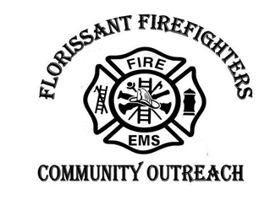
2019 FFCO Golf Tournament
Sponsor Registration

Tournament Sponsor: $1000
- Each Tournament Sponsor will receive a large banner with their logo at the Clubhouse, along with recognition prior to the start and at the awards presentation. Each Tournament Sponsor will also receive a free Foursome for the Tournament. Each tournament sponsor will also receive an appreciation plaque from the Florissant Firefighters Community Outreach.
Dinner Sponsor: $750
- Each Dinner Sponsor will receive a large banner with their logo to be displayed near the dining area, along with recognition prior to the start of the tournament and at the awards presentation. Each Dinner Sponsor will also receive an appreciation plaque from the Florissant Firefighters Community Outreach.
Drink Cart Sponsor: $500
- Each Drink Cart Sponsor will receive a small banner to be displayed with their logo on the drink carts that will be on the course throughout the day. Each drink cart sponsor will receive recognition prior to the start of the tournament.
Individual Hole Sponsor: $100
- Each Hole Sponsor will receive their logo displayed on a sign on an individual golf tee box.
*Please Circle Tournament Sponsor Level

Company Name:__________________________________________________

Contact Information:______________________________________________

